**Sprint 2 Report**

**Product Name:** SummarAIze

**Sprint Completion Date:** May 6, 2025

**Revision Number:** V1.1

**Revision Date:** May 7th, 2025

**Actions to stop doing:**

* The team should stop arriving late to stand-up meetings, because it causes us to repeat information when they arrive if they don’t.

**Actions to start doing:**

* The team should start completing tasks more quickly, because other team members are dependent on the other’s work.
* The team should start holding at least one standup in person a week, because it is more productive and engaging when it is in person.
* The team should start holding work sessions, because we can all collaborate when we work together to become more efficient.

**Actions to keep doing:**

* The team should continue holding regular standups to update our progress.
* The team should continue updating the JIRA board with tasks and their completion status.

**Work completed/not completed:**

* **Work Completed**
  + **As a student, I should have a user account that stores my information so that I can track my progress.**
    - Task 1: Set up database (Firebase) for authentication (1 hr)
    - Task 2: Connect Firebase to backend (2 hr)
    - Task 3: Add authentication to frontend and connect to backend (2 hr)
  + **As a student, I want to choose the summary length (short, medium, detailed) so that I get the right level of depth for my needs.**
    - Task 1: Display summary in frontend (1 hr)
    - Task 2: Incorporate user input for summary length on frontend (1 hr)
    - Task 3: Incorporate user input from frontend to change feature prompt in backend (1 hr)
  + **As a student, I need to be able to play the narrated voiceover so that I can simultaneously absorb information while completing other tasks at hand.**
    - Task 1: Research and add API to generate narrated voice over of summary (2 hr)
    - Task 2: Connect it to frontend (2 hrs)
* **Incomplete**
  + **As an educator, I want to be able to create a visual representation so that I can make presentations so that complex concepts are simplified for students.**
    - Task 1: Extract visuals from research papers (2 hr)
    - Task 2: Research and add API to generate images (2 hr)
    - Task 3: Research and use Python libraries to string together images (3 hr)
    - Task 4: Add animation over visuals (4 hr)
* **Work completion rate: 75%**
  + **User Stories Completed: 3**
  + **Total Estimated Time: 20 hrs**
  + **Total Number of Days: 14 days**
  + **Average user stories / day: 0.25/day**
  + **Average work hours / day: 1.5 hour**

**Scrum Board:**

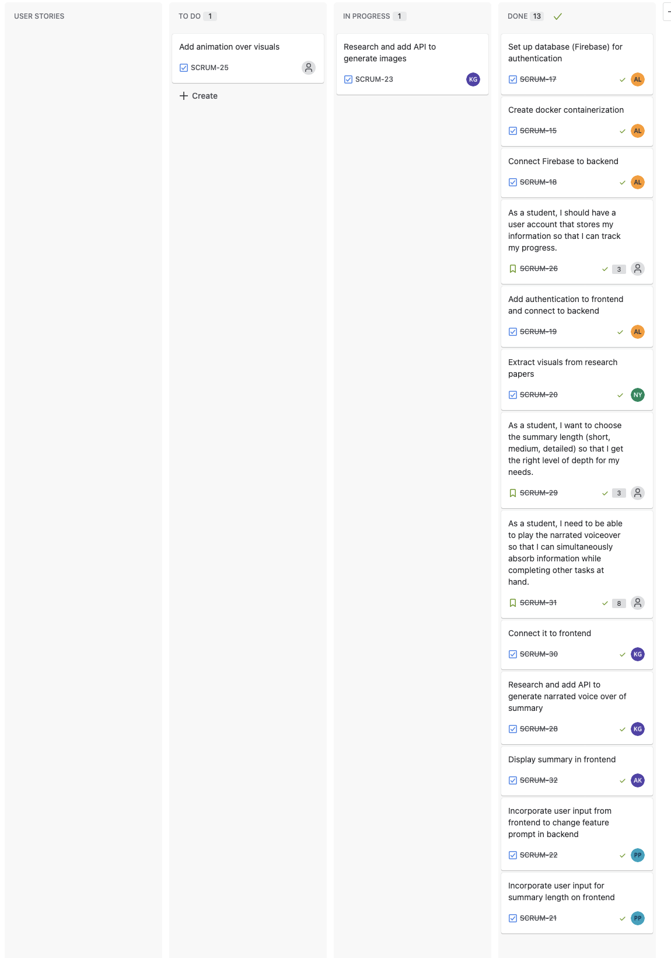

**Burn-up Chart:**

